INSERT TITLE HERE (Main heading is capitalized, center, bold, Times New Roman, 14pt)
Paul Dirac1, Erwin Schrödinger1 and Marie Curie 2* (Times New Roman, Font 12)
¹Department of Food Engineering, Kahramanmaras Sutcu Imam University, Kahramanmaras, Turkey
²Department of Civil Engineering, Kahramanmaras Sutcu Imam University, Kahramanmaras, Turkey (Times New Roman, Font 9)

*Corresponding Author: please fill in (the author and his/her contact e-mail)
ABSTRACT (required field)
Abstract must be written in Times New Roman (10pt). These instructions give you guidelines for preparing your submission. Use this document as both an instruction set and as a template into which you can type your own text. Submission titles should be written in uppercase and lowercase letters, not all uppercase. Full names of authors are preferred in the author field. The author who will make oral/poster presentation must be underlined. Abstract should not exceed 300 words and it must clearly indicate the problem, objectives, research methods, results and conclusions. Abstract must be self-contained, without abbreviations, footnotes, or references. Abstract must be written as one paragraph, and should not contain displayed mathematical equations or tabular material. It is important to avoid over-repetition of phrases. Ensure that your abstract reads well and is grammatically correct.
Keywords: Minumum three, Maximum five keywords, In alphabetical order (Times New Roman, 9pt., upper case at the beginning of each keyword. Keywords should efficiently represent the paper content)

TR BAŞLIĞI BURAYA EKLEYİNİZ
ÖZET (optional field)
Özet, Times New Roman (10pt) ile yazılmalıdır. Bu kılavuz, çalışmanızı hazırlamak için size rehberlik etmektedir. Bu dokümanı hem yazım kuralı hem de içine çalışma metninizi yazabileceğiniz bir şablon olarak kullanılabilir. Gönderim başlıkları büyük ve küçük harflerle değil, büyük harflerle yazılmalıdır. Yazar alanında yazarın tam adı tercih edilmektedir. Sözlü / poster sunum yapacak yazarın altı çizilmelidir. Özet 300 kelimeyi geçmemeli ve problemi, amaçları, araştırma yöntemlerini, deneysel sonuçları ve çıktılar açıkça belirtmelidir. Özet, kısaltmalar, dipnotlar veya referanslar olmadan kendi kendine yeterli olmalıdır. Özet bir paragraf olarak yazılmalı ve görüntülenen matematiksel denklemleri veya tablo materyalini içermemelidir. İfadelerin aşırı tekrarlanmasından kaçınmak önemlidir. Özetinizin iyi okuduğundan ve dilbilgisi doğru olduğundan emin olunuz.
Anahtar Kelimeler: Alfabetik sıra ile en az 3, en fazla beş adet anahtar kelime kullanılabilir. (Times New Roman (9pt) ile her anahtar kelimenin ilk harfi büyük harf ile başlamalıdır.)

INTRODUCTION (second order heading is capitalized, left, bold, 11pt)
Use this document as both an instruction set and as a template into which you can type your own text. Full papers should not exceed 6 pages including abstract, main text, references, figures (diagrams and tables, graphics, maps etc.). Main text should be written using Times New Roman font (10 pt. font size).
Introduction section should be included current studies and contribution of the study.

A NEW SECTION (second order heading is capitalized, left, bold, 11pt)
  - Subsection (third order heading are written in lowercase, bold, 11pt)
Clear original figures should be used. Equations should be numbered consecutively throughout the paper and located at the right margin as in Equation (1) below. Figures and tables should be placed at the top or at the bottom of each page as in Figure 1 and Table 1.
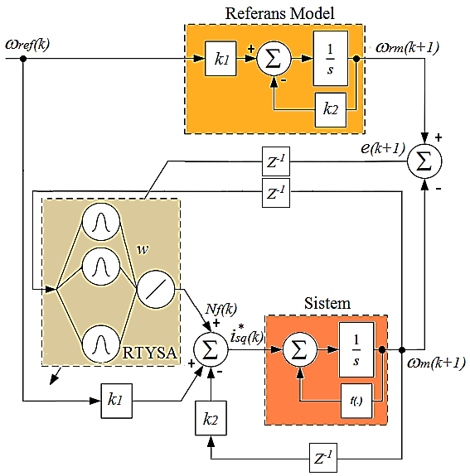
Figure 1. RTYSA-based block diagram of MRAK.

Table 1. The Engine Parameters
Parameters | Values
P | 3 kW
n | 1430 d/d
V | 380 V
I | 6.7 A
M | 19 Nm
p | 2
f | 50 Hz
R_{s} | 1.45 ohm
L | 12.2 mH
R_{r} | 1.93 ohm
L_{r} | 2.66 mH
L_{m} | 187.8mH
F | 0.03 N.m.s/rad
J | 0.03 kg.m²

For instance, Lagrangian function states the difference between system kinetic energy and potential energy as in Equation (1) in which L, T and V refer to Lagrange function, kinetic energy and potential energy of system, respectively.
(1)
- CONCLUSIONS (second order heading is capitalized, left, bold, 11pt)
Authors will be able to monitor the situation of their abstract in the submission interface. At least one of the authors of each accepted abstract shall register for the symposium and pay the registration fee in order to have their abstract included in the Symposium Abstract Book.
- REFERANCES (second order heading is capitalized, left, bold, 11pt)
Acikgoz, H., Kececioglu, O.F., Gani, A., Sekkeli, M. (2014). Speed Control of Direct Torque Controlled Induction Motor By using PI, Anti-Windup PI And Fuzzy Logic Controller, International Journal of Intelligent Systems and Applications in Engineering, 2, 58-63.
Sarıoğlu, M.K., Gökaşan, M., Boğosyan, S. (2003). Asenkron makinalar ve kontrolü, Birsen Yayınevi, İstanbul.
Trzynadlowski, A.M., (2000). Control of Induction Motors. Academic press, USA.
Zhang, M.G., Li, W.H., Liu, M.Q. (2005). Adaptive PID control strategy based on RBF neural network identification, IEEE International Conference on Neural Networks and Brain, 1854-1857.

